Relational Mapping:
A Tool for Assessing and Improving the Relational Core of a Work Process
Relational Coordination Collaborative

What is relational mapping?
Every work process has a relational core whose quality determines whether its diverse participants can coordinate their work effectively - or not. Relational mapping is a tool for assessing and improving this relational core. Participants are invited to choose a work process that they find challenging to coordinate. They identify the roles that are involved, then assess the strength of relational coordination among these roles along the dimensions of shared goals, shared knowledge and mutual respect as well as the frequency, timeliness, accuracy, and problem-solving focus of communication. The result is a shared visual object that depicts a network of multiple, simultaneous role relationships.
Just as process mapping helps to visualize and improve the flow of work, relational mapping helps to visualize and improve the relationships and communication among the people who do the work. Relational mapping allows participants to visualize interdependencies between multiple roles and organizations, and see each component as part of a whole system. The roles on a relational map often include roles that are overlooked such as: roles that are perceived to be of low status; roles from different organizations and sectors such as the public sector and the community sector; and non-work roles such as patients, families, friends and neighbors. Relational mapping often surfaces sensitive and unresolved system dynamics and can serve as an impetus for change by generating new ideas, insights and strategies for addressing complex challenges.
Relational mapping is informed by the theory of relational coordination. Relational coordination is communicating and relating for the purpose of task integration. It is an empirically validated framework for achieving outcomes such as quality, safety, efficiency, client engagement, worker well-being, learning and innovation, particularly when work is highly interdependent, uncertain and time constrained. In this workshop we will create and analyze relational maps as a basis for assessing and improving the relational core of a work process, in order to improve desired outcomes.
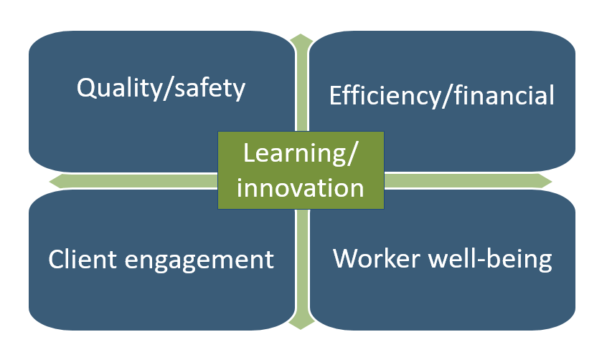
Relational Coordination

Relational coordination (RC) is communicating and relating for the purpose of task integration. RC is particularly useful for achieving a wide array of performance outcomes when work is interdependent, uncertain and time constrained.
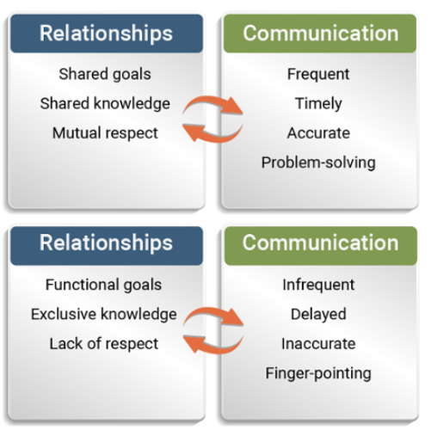
Relational Mapping
The relational pap shows a bird’s-eye view of the strength of ties within and between stakeholders.
- Identify a work process that needs better coordination.
- Which roles are involved? Fill in the circles on the map with the roles.
- Color in the circle to indicate how well each role is coordinating with itself. Draw lines between the roles to show how well the roles are coordinating with each other. You can draw one line or two depending on whether the coordination is the same or different between the two roles. GREEN = HIGH RC, BLUE = MODERATE RC, RED = LOW RC

Assessing Current State
- Where is relational coordination currently working well? Where is it working poorly?
- How does this impact our outcomes?
- What are the underlying causes?
- Where are our biggest opportunities for change?

The Relational Coordination Survey, with its seven questions and network analytics, can be used for a more systematic and inclusive assessment. Visit Relational Coordination Analytics for support.
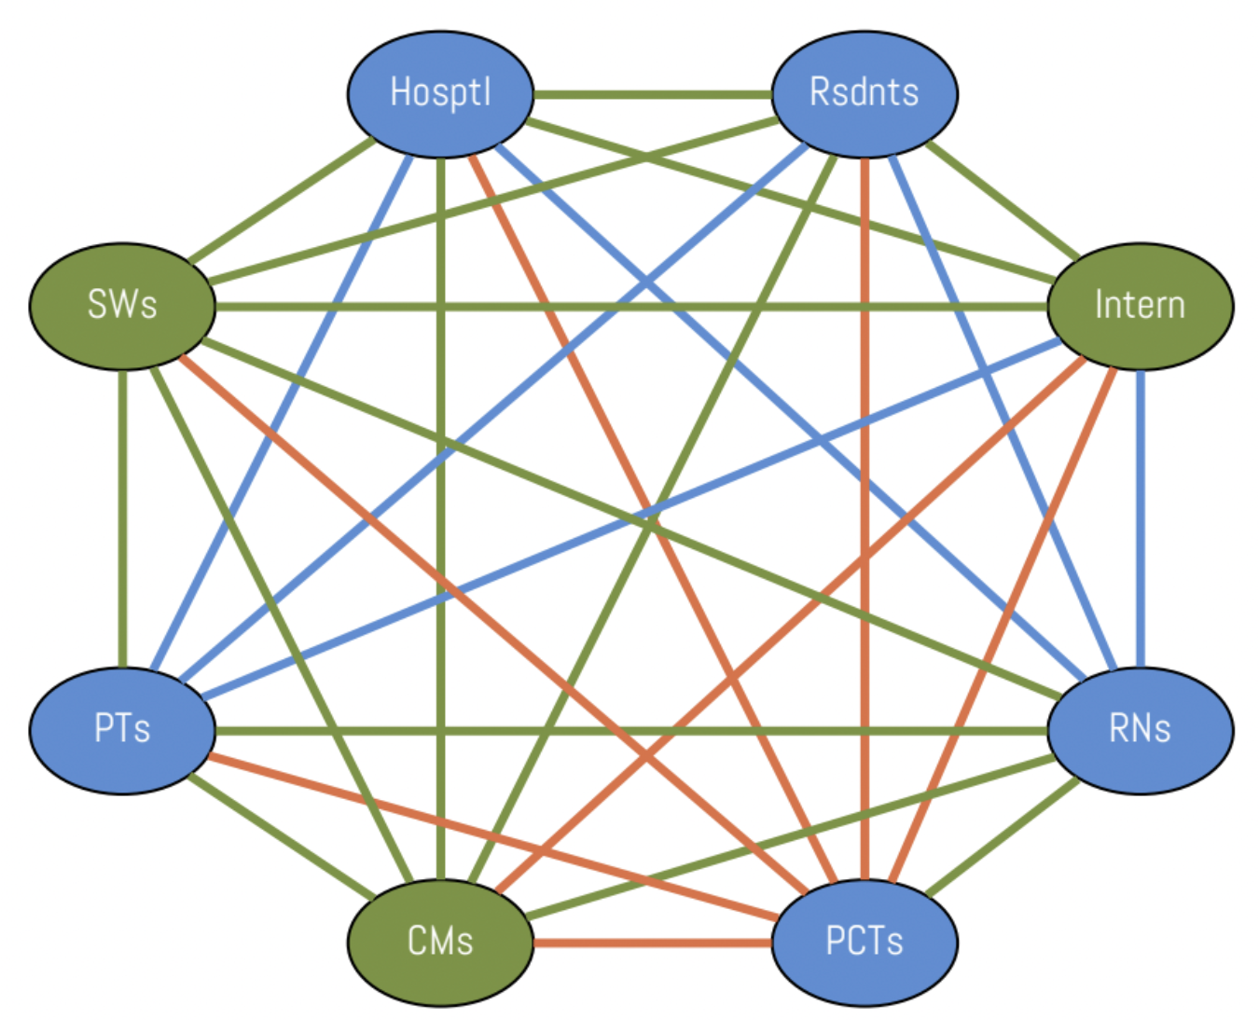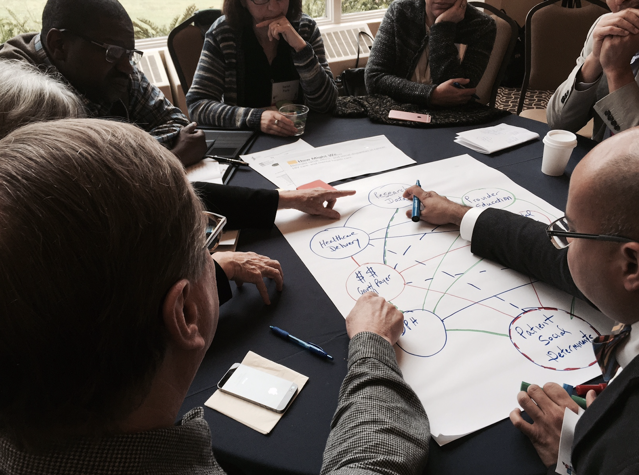
Worksheet for Relational Mapping
What's the work in need of coordination? Which roles should be involved? How well are they currently coordinating?

WORK IN NEED OF COORDINATION
__________________________________________________________________________________________

Relational Coordination Key
--- High RC
--- Moderate RC
–- Low RC

RC Dimension | Survey Questions
Frequent communication | How frequently do people in these groups communicate with you about [work process]?
Timely communication | How timely is their communication with you about [work process]?
Accurate communication | How accurate is their communication with you about [work process]?
Problem solving communication | When there is a problem with [work process], do people in these groups blame others or try to solve the problem?
Shared goals | Do people in these groups share your goals for [work process]?
Shared knowledge | Do people in these groups know about the work you do with [work process]?
Mutual respect | Do people in these groups respect the work you do with [work process]?

